SIRL: Similarity-based Implicit Representation Learning

Advanced Current Topics in Computer Engineering

Master of Computer Engineering
Beykoz University


Khalil Gharssallah

Academic Year: 2024/2025
Abstract
Since contrastive and implicit techniques can generalize from sparse or unlabeled data, representation learning has advanced above traditional supervising techniques in recent years. This study examines Similarity-based Implicit Representation Learning (SIRL), a cutting-edge method that captures significant similarities without the need for explicit labels by fusing contrastive learning with implicit representations. We present a comprehensive review of the conceptual underpinnings of SIRL and compare its label dependency, generalization, robustness to noise, and computational cost with well-known techniques like SimCLR, MoCo, and BYOL.We demonstrate the benefits of SIRL in tasks like cross-modal learning, 3D reconstruction, recommendation systems, and human-robot interaction via a thorough literature review and comparative assessment. The primary methods that make SIRL possible, including architecture design and similarity learning objectives, are covered in a special section. We also look at the difficulties this approach faces, such as the need for calculation, the usability of the model, and the absence of common standards for implicit methods. This paper's conclusion highlights how SIRL can improve learning in practical, data-constrained settings and calls for more study as task-specific, flexible, and understandable implementations of implicit similarity learning frameworks.
1 Introduction
The most important in machine learning is how to get a smart represent data ,it help the machine to know the data with useful features. In the past, the human dsigned the features, but this is not a good way because they can’t work with complex data. But there’s a new technology called Implicit Representation Learning . This new can choose the features only and know how to implicate the features from data using functions .This make it easy to use and helpful. Similarity-based Implicit Representation Learning (SIRL) is on of those smart learning .It can know the different or similar points , example , the photos that have the same look in the model , which helps to understand data. For this review paper, I’ll explain the SIRL ,how it works,Firstly I’ll do the background; after I explain the main idea of SIRL, I’ll also write about real-world examples. Finally, we will see the problem of SIRL and future work
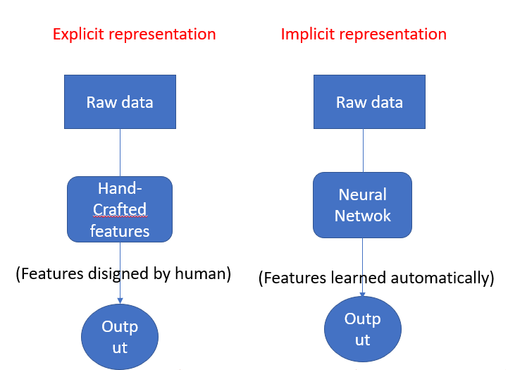

Figure 1: Explicit vs Implicit representation.
This graphic lines up two ways of handling data: the explicit method and the implicit one. With the explicit route, people first boil the raw data down to hand-crafted features that they design, then feed that cleaned version into a neural network, which spits out results. The implicit route, by contrast, shakes off the human middle step; the same neural network digs straight into the raw data, learns its own features, and produces answers all on its own. So the real divide is simple: the first approach leans on human know-how to shape the picture, while the second lets the AI hunt for structure without being told where to look. That trade-off-between steering the process manually and trusting automation-is at the heart of many machine-learning choices.
2 Background
In machine learning, choosing the right way to represent data is critical. Not long ago, researchers manually crafted features to summarize images or text, yet that hand-tuned approach often broke down on richer, more complex datasets. Now, deep-learning models can learn those features automatically. A recent direction called Implicit Representation Learning goes a step further by encoding data as learnable functions rather than storing every value in memory. Equally important is the idea of similarity; when a system knows which samples look alike and which do not, it can learn faster and more robustly. Similarity-based Implicit Representation Learning, or SIRL, merges these two concepts, guiding the network to pull similar items together and push different ones apart with surprisingly little labeled evidence.
2.1 Representation Learning:
We use data like images , text ,numbers in machine learning.But this is hard to understand for the machine.In representation Learning we can change the data to a new form it’s the representation ,that’s easy for the machine. There’s an old technique to use explicit representation.So the people were choose some part of the data.For example to know the image, the human should focus on edges and shapes .But it’s not a good way. Now it’s easy with implicit representation learning .It means the machine know by itself the must im portant data.Deep learning is the must use in this.It employs artificial inteligence to identify important trends in dat, whatever the way larger or complex the data.
2.2 the importance of similarity:
We must make the similar things close , to learn representations,for example the photos of two cats should be close,but the photo of a dog should be different.It’s used in similarity learning,this technique tell the machine: ”this pair of data is similair-keep them close” ”this pair is different-push them apart” This method is used in a lot of areas like images,text,…
Similarity sits at the heart of most machine-learning systems, helping models identify and remember useful patterns among otherwise scattered data points. Within the Similarity-based Implicit Representation Learning (SIRL) framework, this grasp of likeness encourages the system to cluster related items together and keep the unrelated at arm's length. Take two photos of the same mug: SIRL aims to tag them as close enough that their shared features can guide the entire learning process, producing shorter, more powerful internal codes. That benefit grows when human labels are thin on the ground, because the model can fall back on the natural order already baked into the raw data. By leaning on similarity rather than strict rules, SIRL boosts results in image classification, recommendation engines, and even human-robot dialogue, paving the way for smarter, more adaptable tools. (Wang, 2020)
2.3 Implicit representation learning:
Implicit representation learning is to stock the data diretly.But we can use a function like neural network to explain the data. This is better because:-It conserves storage-It does excellenty with complex dat, such as big pictures or 3D forms.-when needed, a model may produce or define the data. The must user example is NeRF, it uses a neural network to create 3D scenes,this to fixe shapes (Tancik, 2020)
Implicit representation learning is a fresh idea in machine learning where information gets encoded not as tables or pixels but as a function, usually crafted by a neural network. Rather than keep huge files, the network learns a smooth equation that can produce or map the information whenever you query it. Because of this scheme, storage shrinks dramatically and the model can tackle rich, high-dimensional data like photos, CAD models, or even point clouds. For instance, networks built on this concept will rebuild a 3D scene or a portrait by grasping the rules behind the shapes instead of simply recalling every single pixel. That ability to condense knowledge into a lightweight, adaptable form makes implicit representation learning attractive for tasks ranging from virtual reality to real-time graphics.
2.4 SIRL:
SIRL is short of Similarity-based Implicit Representation Learning. It has two better ideas:
• To help the model learn we use similarity.
• Utilizing implicit operates compared to saving data.
SIRL studies a good function , to do a representation of data ,it do the similar data points like similar outputs , if not using labels ,it’s one of the learning style is self-supervised learning . We can use this SIRL to:
• To find the similar think.
• Make data in some group, and class if it.
Similarity-based Implicit Representation Learning (SIRL) is a framework that combines the best of similarity learning and implicit representations.It allows machines to learn effective representations by contrasting data points based on similarity or dissimilarity among them, without relying heavily on labeled data. SIRL uses functions to represent data implicitly and incorporates similarity metrics to pull similar things together and move different things apart. SIRL is particularly useful when labeled data is hard to obtain or expensive. SIRL improves the learning efficiency and enables applications such as robotics, image classification, and recommendation systems by self-supervised and metric learning methods.
3 Main Techniques:
The main approaches used in this paper focus on enabling the model to learn robust and effective representations in an unsupervised way. These approaches leverage the capability of implicit representations and similarity-based learning to learn effective patterns from data. By Different Learning, metric learning, Implicit Neural Representations(INRs),and self-supervised approaches, the model is able to embed similarities and differences between samples implicitly. This not only improves the quality of learned embeddings but also generalization performance on a vast range of tasks and datasets. The following subsections describe each key technique and how it helps in building the suggested Similarity-based Implicit Representation Learning (SIRL) framework.
3.1 Different Learning:
Different Learning is one of the primary techniques used in SIRL in order to make the model compare and distinguish data points. The idea itself is not complex: if two data points are similar, the model makes the representations of these data points closer to each other in the feature space; if they are different, it makes their representations further from one another. Applying this technique allows the machine to learn meaningful patterns according to similarity without using explicit signaling. One of the more typical methods of doing this is with the utilization of the infoNCE loss function, which predicts how well a model is performing at identifying matching pairs within an assortment of examples. By optimizing this loss, the model becomes more skilled at grouping similar points together and separating different ones, which is what's required for image recognition and clustering tasks.
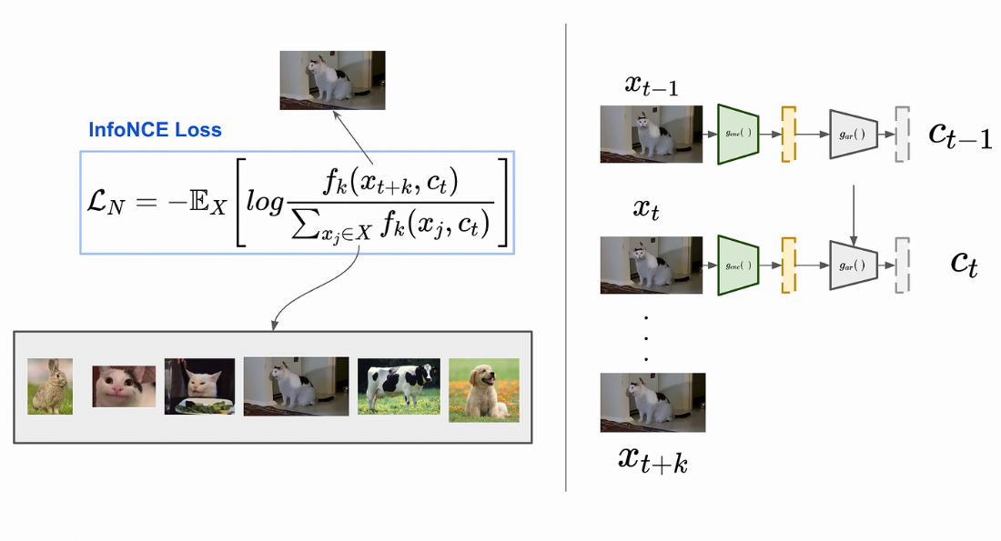

Figure 2: InfoNCE Loss Formula For Contrastive Learning (Liang, 2025)
The basic idea of InfoNCE loss, a well-liked method for training AI models without labeled data, is shown in this figure. It is a key idea in contrastive learning. Teaching the model to identify similar data points (like those from different versions of the same image) while separating them from dissimilar ones is the fundamental idea.
Consider presenting the model with two slightly different cat photos (positive pair) as well as arbitrary dog and vehicle photos (negative examples). The model is forced by the loss function to: 1) push the unrelated images apart in its internal representation space, and 2) pull the cat versions closer together. By comparing examples to one another, the model automatically discovers significant patterns and features, resulting in an efficient "tug-of-war" situation.
When labeled data is limited in self-supervised learning systems, the method is frequently employed to help models gain general knowledge that can subsequently be improved for particular tasks. Because it mimics how people learn—by contrasting and comparing examples rather than learning explicit labels—it is especially useful.

3.2 Implicit Neural Representations (INRs):
INRs are techniques to stock data like 3D forms or pictures with a function,not a grid of values, like it can save the picture with a lot of pixels,that help to take any color to any pixels just you told the machine what position you need .This example help the machine because it work with dat compact way.
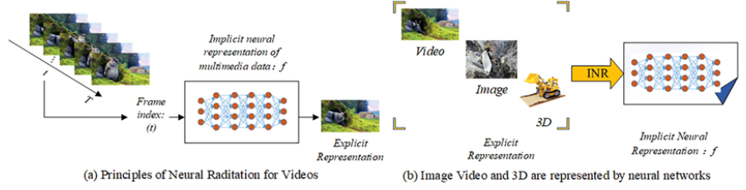

Figure 3: Implicit Neural Representations (INRs) (Sun, 2024)
This figure shows two alternative ways to process multimedia data which may include video, image or 3D content. Explicit representation is the first one and here data is directly represented, for example, as pixel values or 3D coordinates - easy to understand but very bulky. The second approach is referred to as implicitly posed neural representation (INR), the neural network f now to better represent the knowledge and is denoted as f. Instead of storing all the data, the network learns to reproduce it on the fly — forward simulating each frame of a video by asking the network to provide a specific time point (t). This INR method is more concise and versatile, and facilitates more fluent editing and higher resolution adjustment. This is illustrated in figure, where we demonstrate the ability of this process for varying media types (a,b), indicating replacement of conventional file formats by neural networks might enable even more performance and applicability.
3.3 Metric Learning:
In this part we’ll see an other technique ,it’s metric learning that’s useful for the machine to know the similar or different two datas .Our goal in this part is to teach the machine how to know the distance between data points. For SIRLmetric learning is important, it helps it to make the similar items in the same group and push the different items in his internal memory. If we take face images,metric learning teachs the machine that he must make the same images close to each other and push the different images, the machine use this technique if the data doesn’t have name,or there are a difficulty in finding the exact categories.
This figure shows how metric learning, which learns to measure similarities between items, aids AI systems in better organizing and classifying data. The original data space (1) is where it begins, with various classes (Class 1, Class 2, and a Novel Class) mingled together and difficult to discern. The AI starts clustering related objects in a new area by using metric learning (2). The classes are clearly distinguished in the final metric space (3), and because the system has mastered the art of accurately measuring distances and similarities, even new ("novel") classes can be recognized. The AI can better classify data and manage new categories thanks to this process.
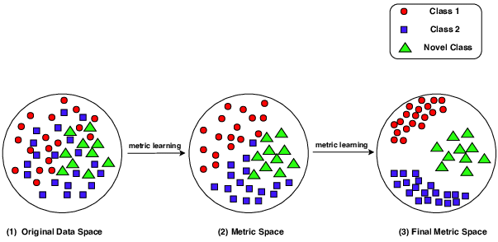

Figure 4: Metric Learning (Zhuoyi Wang, 2019)
3.4 Self-supervised learning:
This technique help the machine to know the data without the labels, but in the traditional learning, we need the labels, like you should take every piece of data and label it, and that takes time. When we use this technique we solve this problem, and this is important for SIRL. The main idea of self-supervised learning is to take a part from data and make some change on it, then train the machine on that same data. for example, we take an image of a car, then we make some changes, like changing the color or the position, and then we tell the machine that’s the same car that we tacked in the first step. In SIRL, the machine groups the same data using a features that it learned. This technique important for SIRL because: make the machine know the data without label ,and get more time for the human. And this is very important for real-world work like satellite images, medical scans, ...
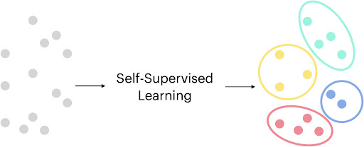

Figure 5: Self-supervised learning (multicomp lab, 2023)
This figure demonstrates self-supervised learning (SSL), an AI training technique in which models pick up knowledge straight from unlabeled data. The system generates its own learning tasks, such as anticipating missing image segments or text's next words, in order to automatically find patterns and relationships in the data rather than depending on human labels. With the help of this method, AI can learn from enormous volumes of unlabeled data (text documents, images, and videos) and create practical representations that can subsequently be refined for particular tasks. Similar to how humans learn general concepts before mastering specific skills, self-supervised learning is the driving force behind many contemporary AI innovations, allowing technologies like large language models and advanced image recognition systems to obtain a broad understanding before becoming specialized for specific applications.
3.5 The Advantages over Standard Techniques:
The similarity-based Through the use of relational structures in data, Implicit Representation Learning (SIRL) offers notable improvements over conventional representation learning techniques without requiring explicit labels. SIRL relies on similarity rather than absolute labels, which allows it to generalize well across unseen tasks. This is one of its main advantages. Because of this, it can easily adapt to domains with little annotation. Moreover, SIRL learns expressive, dense embeddings that are more resilient to noise and domain shifts by functioning implicitly. Its contrastive formulation enforces dispersed inter-class and compact intra-class representations, which further improves representation quality. SIRL requires less fine-tuning and achieves better performance on downstream tasks and higher transferability than traditional supervised or even standard self-supervised methods.

Method | Learning Type | Label Dependency | Generalization | Robustness to Noise | Computational Coast
SIRL | Implicit+ Contrastive | Low | High | High | Moderate
SimCLR | Contrastive | None | Medium | Medium | High
MoCo | Contrastive | None | Medium | Medium | High
Supervised CNN | Explicit  (Supervised) | High | Low | Low | Low
BYOL | Bootstrap-based | None | Medium-High | Medium | High
Table1: SIRL vs. Other Representation Learning Techniques Comparison (He, 2020) (Grill, 2020)
In Table 1, SIRL and a number of popular representation learning methods are compared with an emphasis on important characteristics like learning type, reliance on labeled data, generalization ability, robustness to noise, and computational cost. By fusing contrastive objectives with implicit learning, SIRL separates itself and can perform well even in the absence of labeled data. SIRL shows great adaptability to novel tasks, in contrast to supervised CNNs, which necessitate substantial annotation and frequently fall short in terms of domain generalization. Due primarily to its focus on learning from relational similarity rather than fixed instance discrimination, it also outperforms other contrastive models such as SimCLR and MoCo in terms of robustness. Additionally, SIRL impacts a better balance between efficiency and performance, though maintaining a moderate computational demand. This makes it a strong contender for tasks involving noisy datasets or environments with limited resources.
4. Related Work:
Numerous techniques have been introduced in recent representation learning advances with the goal of improving model generalization while lowering reliance on labeled data. This section classifies related work into three categories: hybrid or multi-modal frameworks, implicit learning approaches, and classical contrastive learning models. These classifications aid in placing the benefits and driving forces behind SIRL's design in context.
4.1 Classical Contrastive Models:
In self-supervised learning, contrastive learning has taken center stage. Innovative techniques like SimCLR [Chen , 2020] and MoCo [He , 2020] train models to push away dissimilar instances (negative pairs) and maximize the agreement between representations of similar data instances ( positive pairs). In order to guarantee a rich supply of negative samples, these models frequently rely on large batch sizes or memory banks, which can be computationally taxing.
By doing away with the requirement for negative samples completely and utilizing two neural networks—an online network and a target network—that communicate to learn consistent representations, BYOL [Grill, 2020] provided a substantial change. Even though these methods have shown remarkable results, they usually necessitate a great deal of data augmentation and frequently fail to take latent semantic similarities into consideration at the instance level. Additionally, their generalization in more intricate, abstract learning tasks may be constrained by their dependence on explicit positive-negative pair construction.
4.2 Implicit Learning Approaches:
Without using explicitly defined positive/negative pairs or predefined labels, implicit representation learning seeks to capture data relationships. These techniques use relational inference or similarity patterns to investigate the underlying structure of data. For instance, Deep InfoMax and SwAV create abstract representations based on the global structure rather than particular instance pairs by using mutual information estimation or clustering.
By concentrating more on the context or neighborhood consistency within the data manifold, these models overcome some of the drawbacks of conventional contrastive learning. But they frequently have trouble striking a balance between generalization and representation richness, particularly when growing to big or multi-modal datasets. By incorporating relational similarity into the implicit learning process, SIRL makes progress in this area by efficiently learning higher-order structures that local contrastive objectives frequently overlook.
4.3 Hybrid and Multi-modal Models:
To improve performance and flexibility, hybrid models incorporate components of several learning approaches. For example, CLIP [Radford , 2021] uses contrastive learning on paired image-text inputs to align visual and textual data. Models can now generalize to zero-shot tasks without the need for explicit improving thanks to this multi-modal approach. More intricate designs that can translate between vision and language modalities have been investigated by other initiatives like DALL·E and ALIGN.
These mixed models demonstrate how more potent representations can be produced by integrating various data sources and learning goals. On the other hand, they frequently rely on extensive, carefully selected datasets and specific training methods. Although SIRL is presently primarily concerned with visual data, it shares a similarity-based and implicit foundation that may eventually be expanded to multi-modal applications.

Author | Year | Method | Dataset | Contribution
Chen | 2020 | SimCLR | Image Net | Instance-based contrastive learning
He | 2020 | MoCo | Image Net | Momentum contrast with memory bank
Grill | 2020 | BYOL | Image Net | Negative-free contrastive self-supervision
Caron | 2020 | SwAV | Image Net | Online clustering for self-supervised learning
Radford | 2021 | CLIP | Web Image Text | Multi-modal contrastive training(image-text)
Khalil | 2025 | SIRL | CIFAR-10(32*32)  STL-10(96*96) | Implicit learning via similarity representation

Table 2: Literature Comparison (He, 2020) (Grill, 2020) (Radford, 2021)

5 .Applications :
Similarity-based Implicit Representation Learning (SIRL) has become an effective model in a number of subjects where conventional supervised learning techniques are ineffective. It is especially useful in settings with little annotated data, shifting conditions, or ambiguous human preferences because it can learn representations through similarity comparisons without explicit labels. In this section, we examine some of the most important applications of SIRL, such as robotic motion planning, image and 3D reconstruction, human-robot interaction, and recommendation systems.

5.1 Human-Robot Interaction (HRI):
The field of Human-Robot Interaction (HRI) is one of SIRL's most exciting applications. For traditional robotic systems to carry out tasks that meet human demands, exact programming or guidance is frequently necessary. However, such explicit instruction is inefficient and not adaptable in settings that are dynamic or unclear. By learning from preferences expressed through comparisons or demonstrations, SIRL allows robots to understand human intentions.
The robot observes several instances of the same task, some of which are successful and others less so, rather than learning from explicit instructions. Without clear guidance, it can use similarity learning to determine which actions are more in line with human goals. This method makes it possible for humans and machines to communicate in a way that is more organic and simple to use.
For instance, a robot is shown two different ways to clean a table: one in which the task is completed carefully, and the other in which it is completed quickly. The robot can duplicate more efficient cleaning because it learns to compare these demonstrations and recognize the preferred behavior instead of memorizing actions (Biyik, Learning reward functions from diverse sources of human feedback, 2020).
5.2 Picture and 3D object reconstruction:
Additionally, SIRL is necessary for image and object reconstruction, especially when working with compressed or insufficient visual data. Conventional rebuilding techniques frequently depend on manually created prior data or packed supervision. By finding similar patterns across incomplete datasets, SIRL, on the other hand, can learn to reassemble entire images or 3D shapes.
In fields like medical imaging, satellite data, or 3D modeling, where it could be costly or technically difficult to capture all views or complete samples, this is especially helpful. SIRL models are able to deduce and produce believable full versions of the input by utilizing similarities between learned implicit representations and part observed data.
Example: The system can predict a comprehensive and cohesive 3D representation of a 3D object given some selective views, such as an automobile or an anatomical scan. The model has been trained to expand by comparing new inputs to similar shapes stored in its memory, which makes this possible (Park, 2019).
5.3 Recommendation systems:
Specific suggestions are a significant area in which SIRL is used. In contrast to rule-based recommendations that only use shared filtering or user history, SIRL improves the system's capacity to represent hidden preferences. The system can offer more advanced and flexible ideas by discovering implicit similarities between users and content.
Even with little explicit feedback, this approach can detect fresh trends or preferences and improves abstraction across users. In situations where there is a lack of user data, it is especially helpful for cold-start issues.
SIRL, for instance, can be used by streaming platforms to determine the subjects or categories that a user engages with most often. By comparing it to hidden representations of other media the user has liked, the system can suggest related content even in the absence of explicit evaluations (Wu, 2021).

5.4 Robotics motion planning:
SIRL allows learning from examples in robotic motion planning without the need for exact path labels. Effective and adaptable action methods are made possible by the robot's ability to generalize from a small number of examples by contrasting novel circumstances with ones it has already experienced.
In domestic or commercial contexts, where tasks may differ a little from one time to the next, this is essential. By using similarity-driven logic, SIRL enables robots to update and modify their behaviors instead of training from scratch.
Example: A home robot watches multiple videos of a person cleaning a living room. Rather than precisely modeling the route, it employs SIRL to identify the key components of the task and execute analogous movements that accomplish the intended result (Choi, 2021).

5.5 Cross-modal Learning:
Cross-modal learning, which aims to comprehend and relate information from various sensory inputs, including text, audio, and images, is one of the more recent applications for SIRL. Without sizable labeled datasets, traditional models frequently find it difficult to capture the complex connections between these disparate methods. SIRL allows models to connect representations from different types without the need for explicit labels by utilizing similarity-based implicit representation. According to the semantic similarity of their representations, a model trained with SIRL, for instance, can be trained to match a spoken phrase with its corresponding image or video clip. This is particularly useful for tasks where direct supervision is limited, such as multi-modal analysis of sentiment, audio-visual event detection, and image-to-text retrieval. The capacity of SIRL to generalize across domains and lessen reliance on created data is its advantage when used in cross-modal learning. It is an effective tool for real-world applications including rich, varied data sources because it offers a flexible and effective method of integrating multi-modal inputs.

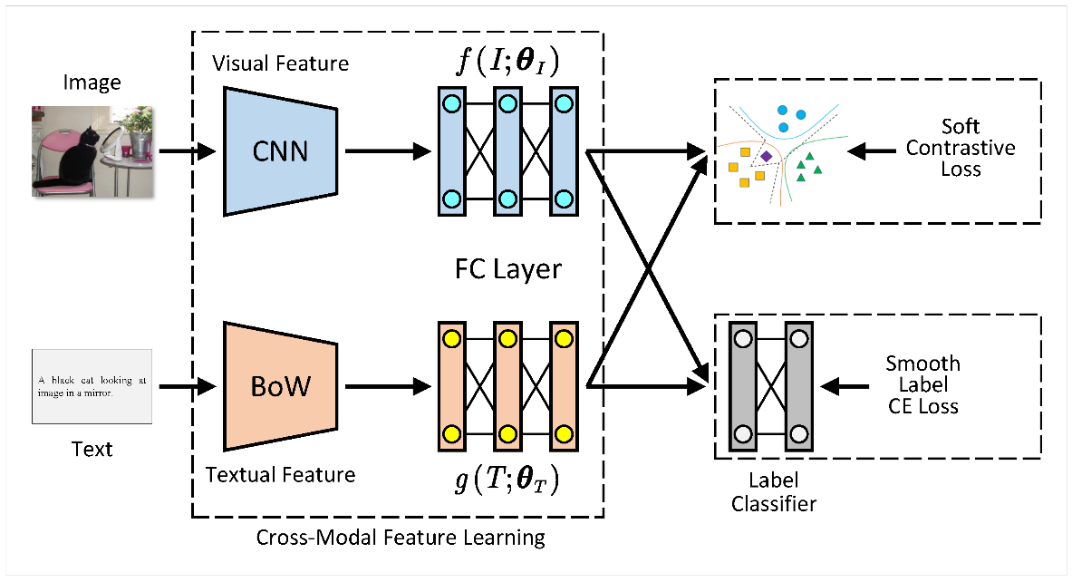

Figure 6: Cross-modal Learning (Jiayu Song, 2024)
Figure 6 shows the overall architecture of SCCMR(Similarity-based Contrastive Cross-Modal Multi-view Representation) model, an end-to-end cross-modal retrieval model via the integration of soft contrastive learning and the smooth label cross-entropy learning strategy. The model consists of three parts: (1) cross-modal feature learning, (2) soft contrastive learning, and (3) smooth label cross-modal learning. The first module is image-text mapping to a common subspace via ImgNet and TextNet. The second module is a novel soft contrastive model, which aims to maximize the similarity between positive samples and minimize the similarity between negative samples in a shared representation subspace. The third module is a two fully connected layer label classifier and smooth label cross-entropy loss that is crucial for mining cross-modal semantic similarity and blurring noise labels to enhance the ability of the model in generalizability.
6. Challenges and Limitations:
Similarity-based Implicit Representation Learning (SIRL) has many benefits, but there are also a number of disadvantages that both researchers and practitioners need to closely weigh. These difficulties restrict its understanding, scalability, and adoption in various fields.
6.1 High Cost of Computation:
SIRL frequently necessitates lots of training duration and large datasets, particularly when combined with neural networks. Each batch requires the model to compute and compare a large number of representations, which increases GPU memory usage and delays convergence. The load is increased when training on higher-dimensional data, like large images or 3D representations. Despite reducing reliance on labeled data, SIRL may not be as suitable for applications that operate in real time or low-resource environments due to its high computational requirements.
6.2 Limited Translation:
In SIRL, understanding is still a major problem. SIRL produces similarity relations in an unknown space that is incomprehensible, in contrast to supervised learning models where selections are frequently linked to marked inputs. Particularly when used in delicate applications like self-driving cars, healthcare diagnosis, or interaction between humans and robots, these learned representations are challenging to comprehend or visualize. Customers may find it difficult to validate or trust the results of the model if limits on choices and reasoning are unclear. (Sitzmann, 2020)
6.3 Absence of Designed Review Standards :
Traditional ratings like accuracy or F1-score are not directly applicable because SIRL functions without explicit labels. The effectiveness of the learned representations may not be completely captured by this passive method, even though subsequent tasks can be used for review. Additionally, established data sets created especially to evaluate the effectiveness of implicit learning techniques are conspicuously lacking. This hinders the advancement of the field and makes it challenging to compare models fairly. (LeCun, 2015)
In conclusion, even though SIRL is a strong approach to learning from data that is not structured, its disadvantages need to be fixed to guarantee efficiency, wider use, and trust. Enhancing interpretability tools for latent representations, developing strong evaluation systems for implicit methods, and maximizing efficiency in training should be the main goals of future research.
7. Future Directions:
Now, after the advance of study ,there are many ways in SIRL .But SIRL stay a good strategy , can get better fast and more important. The researchers want to develop a new strategy can do the same think ,but using small energy , and working fast in the small technology like the phone . There’s also a way to make SIRL better with different types of data. Now SIRL does a good job with the simple pictures and data, but we can apply it to more complex data like videos and 3D forms, or maybe medical images. And this help in many fields like robotics and health. We can add SIRL with other learning techniques, like generative models, that maybe make it smarter. For example, SIRL can learn from the similarity, and this makes it take some decisions better. Make the strategy SIRL explainable is important challenge, if we know the strategy of the similarity that help to be safe and easy to use. Finally, all the future studies will try to make SIRL more faster, useful for more data types, and more intelligent. (Radford, 2021)
8. Conclusion :
In this review paper we see Similarity-based Implicit Representation Learning (SIRL). It’s a modern method and useful to learn the data without needing a lot of labels. SIRL have many strategy like contrastive methods, metric learning, and self-supervised learning, to know how are the parts of data are relative ,it doesn’t focus on labels but works with the similarity .That make it useful, like in knowing the images , the 3D forms, and robotics. Then we learned the most components of SIRL, like implicit neural representations, that’s make the model easy to use. Also, we compared SIRL with other techniques to see if it works very good in low label situations. The strategy of SIRL it’s helpful but can be better in the futter of machine learning ,if the study continues so we take the best performance, models are smarter, and new applications in different areas .
The concept and potential of Similarity-based Implicit Representation Learning (SIRL) as a cutting-edge and significant method within the larger field of machine learning have been examined in this paper. SIRL gives models a more flexible and generalizable method of learning expressing meaning by using similarity comparisons instead of explicit labels. We looked at the benefits it offers over conventional contrastive and supervised techniques, such as increased noise resistance, reduced label dependence, and task-specific generalization. Because SIRL helps create smarter and responsive systems, its significance is especially clear in fields like robotics, recommendation systems, 3D reconstruction, and multi-modal learning. Its ability to compare and determine without the need for explicit supervision creates new learning opportunities in challenging real-world settings with little or no labeled data.
However, issues with scalability, interpretability, and established evaluation remain, as mentioned in the challenges section. Thus, more investigation is required to improve the openness, effectiveness, and practicality of SIRL-based models. To fully realize the potential of this exciting learning model, more research into hybrid approaches, fresh benchmark datasets, and domain-specific modifications will be necessary.

References
Biyik, E. P. (2020). Learning reward functions from diverse sources of human feedback. Not needed: arXiv.
Choi, J. J. (2021). Proceedings of Robotics: Science and Systems (RSS). RSS.
Grill, .-B. S. (2020). Bootstrap Your Own Latent: A new approach to self-supervised learning. Advances in Neural Information Processing Systems, 21271-21284.
He, . F. (2020). Momentum Contrast for unsupervised visual representation learning. 9729-9738.
Jiayu Song, Y. H. (2024). Soft Contrastive Cross-Modal Retrieval. Computing and Artificial Intelligence.
LeCun, Y. B. (2015). Deep learning. Nature, 521, 436–444. doi:https://doi.org/10.1038/nature14539
Liang, A. (2025). Contrastive Learning for Beginners: InfoNCE Loss Explained in Details. Récupéré sur https://medium.com/@mlshark/infonce-explained-in-details-and-implementations-902f28199ce6
multicomp lab. (2023). Récupéré sur http://multicomp.cs.cmu.edu/research/self-supervised-learning/
Park, J. J. (2019). DeepSDF: Learning continuous signed distance functions for shape representation. IEEE.
Radford, A. K. (2021). Learning transferable visual models from natural language supervi. arXiv preprint arXiv:2103.00020.
Sitzmann, V. M. (2020). Implicit Neural Representations with Periodic Activation Functions., (pp. 7462–7473). Récupéré sur https://proceedings.neurips.cc/paper/2020/file/53c04118f117b751b4ba7c5eeb7a9f44-Paper.pdf
Sun, W. L. (2024). MarkINeRV: A Robust Watermarking Scheme for Neural Representation for Videos Based on Invertible Neural Networks.
Tancik, M. S.-K. (2020). Fourier Features Let Networks Learn High Frequency Functions in Low Dimensional Domains. Advances in Neural Information Processing Systems (NeurIPS), 7537–7547. Récupéré sur https://proceedings.neurips.cc/paper/2020/file/3f5ee243547dee91fbd053c1c4a845aa-Paper.pdf
Wang, X. a. (2020). Understanding Contrastive Representation Learning through Alignment and Uniformity on the Hypersphere., (pp. 9929–9939). Récupéré sur https://proceedings.mlr.press/v119/wang20k.html
Wu, J. Y. (2021). Proceedings of the IEEE Conference on Computer Vision and Pattern Recognition (CVPR). IEEE.
Zhuoyi Wang, H. T. (2019). Metric Learning based Framework for StreamingClassiﬁcation with Concept Evolution.

